### Radar Processor Software

#### ORS

The Wartsila Voyage Solutions radar processor ORS is the product family dedicated to work with Wartsila Voyage Solutions VTS “NAVI-HARBOUR” and its derivatives.

The required host computing facility is an industrial grade PC working under Windows 7 Operating System or higher. The ORS shall be installed next to the radar sensor.

The radar processor ORS can be configured in a hot-stand-by configuration to increase the level of the reliability and MTBF.

#### ORS Functionality Specification

The ORS designed for a fully automatic operation. In order to ensure the best system performance, each radar processor adjusts individually considering distinctiveness of radar site, considering the location surroundings.

The basic functions of the ORS are:

* radar video conversion to digital form;
* target detection (extraction);
* target tracking, measurement of position and dynamic parameters;
* fine grid masking and signal compression to minimize the data transferring rate of the communication link to the central data processing facility (VTMIS Control Centre);
* enable remote radar control.

In addition to the main functions, the ORS performs several ad hoc functions to guarantee the highest quality of the radar picture and of target tracking in adverse conditions.

These functions are:

* Auto-adaptive Sensitivity Control (in range and azimuth) achieving the maximum probability of target detection in the radar coverage area
* Auto-adaptive Threshold Control (in range and azimuth) and advanced algorithms for stable tracking targets in the close radar vicinity;
* Auto-adaptive Sea Clutter Control and cumulative algorithms to maximize discrimination of a small targets from the sea clutter;
* Automatic steady tracking targets in proximity and merged targets;
* Automatic tracking targets in the radar shadow areas;
* Automatic compensation of the antenna squints, sidelobes and secondary reflections;
* Automatic radar calibration by the radar reference points;
* Automatic compensation of the radar power characteristics changes;
* Automatic compensation of the Earth Curative;
* Automatic comparison.

#### Radar Control

Operator can choose in NH Sensor>Radars menu item. The Radars window opens.

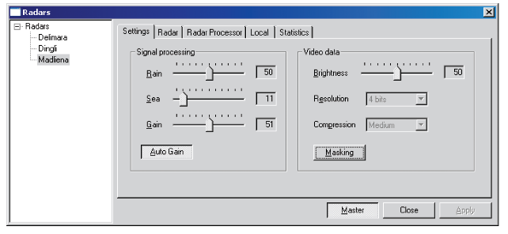

Figure 3‑7 Radar Settings Control Menu

Select the radar name from the tree view at the left. Make sure that the button “MASTER” is pressed.

The following tabs are in the Radars window:

* **Settings** – adjustment of the following filters for the processing of a video signal from the radar processor:
  + Rain – suppression of rain clutter. Working value is 50;
  + Sea – suppression of sea clutter;
  + Gain – radar signal gain.

“AUTO GAIN” - a click the button turns on the automatic tuning of the Sea and Gain filters (recommended). The tuning time is 15-20 minutes. If the weather conditions change very fast, it is best to tune the Sea and **Gain** manually, and then switch to the automatic tuning again.

“Masking” - a click the button turns on the radar video masking in the video masking areas on the ORS sensor chart (recommended).

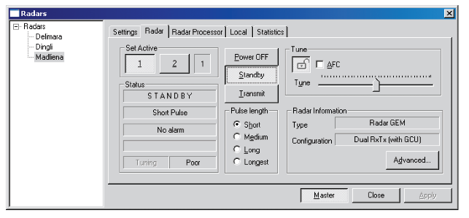

Figure 3‑8 Radar Control Interface

Radar – radar control

To turn on the radar:

Click the “STANDBY” button. The first line of the Status section will display the word WARMUP, the radar warming up will start. Wait until the radar switches to the STANDBY status.

Check that the radar antenna rotation is in no way impeded.

Click the “TRANSMIT” button. The radar will switch to the TRANSMIT status.

To turn off the radar:

Click the “STANDBY” button and wait until the radar switches to the STANDBY status.

Click the “POWER OFF” button. The radar will switch to the POWER OFF status.

Pulse length – radar pulse length. The pulse length is switched by using the radio buttons.

If the radar has a dual configuration, the switching of the active radar is made by using the buttons “1”,”2”.

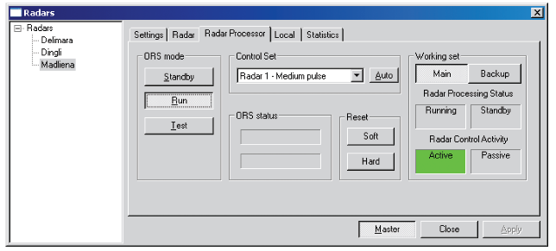

Figure 3‑9 Radar Processor Control Menu

In the case of duplex ORS radar processor configuration, to switch from one set to the backup, use the following procedure:

Switch to the Radar processor tab

Click the “BACKUP” button to switch to the standby radar processor.

Local – setting up the radar video signal display on the ODU screen

Gain – high signal level is shown with more saturated colours, whereas the low-level signal becomes less bright or disappears.

Correlation – correlation between the number of antenna revolutions and the display of the received echo. 1 out of 1 – no correlation. All the received signals are displayed in each antenna revolutions. 2 out of 3 – the signal is not displayed unless it appears at least 2 time in three antenna revolutions. 4 out of 4-х – the maximum correlation: the signals are not displayed unless it appears at least 4 times in four antenna revolutions. With the low correlation level, the displayed signal noise level is high, whereas with the high correlation level fast moving targets are lost.

Highlighting persistent targets – a stable signal is shown in more saturated colour.

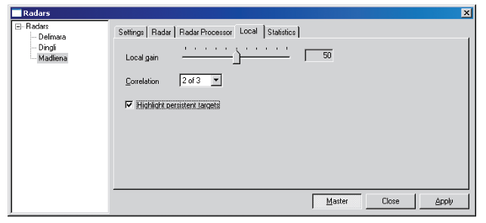

Figure 3‑10 Radar Processor Control Menu

#### VARP31

VARP31 program performs the following tasks:

* Receives raw radar data (radar video outputs) in the analogue or digital form;
* Processes raw radar data for its display and detects and tracks radar targets;
* Tracks automatically radar targets and calculates their movement parameters;
* Transfers radar video and tracked targets to the VTMIS Server;
* Provides local display of radar video and radar targets for the adjustment and maintenance purposes.

The VARP31 program settings are required to be in line with the listed tasks.

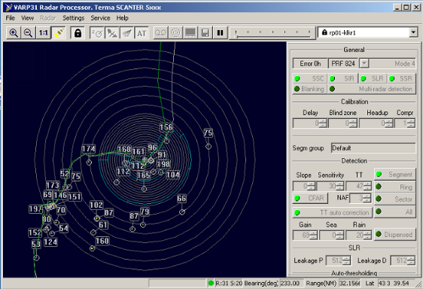

Figure 3‑11 Varp31 Program Interface

The following setup procedure was implemented:

* Set up reception of radar video;
* Make basic radar settings consistent with the radar rated data;
* Calibrate radar video;
* Create radar video masking areas and tracking prohibited areas for the port area;
* Make optimizing of automatic sensitivity control (ASC) settings and tracking parameters settings.

#### Radar Diagnostic

The radar status is shown on the Diagnostics panel in the Radars section.

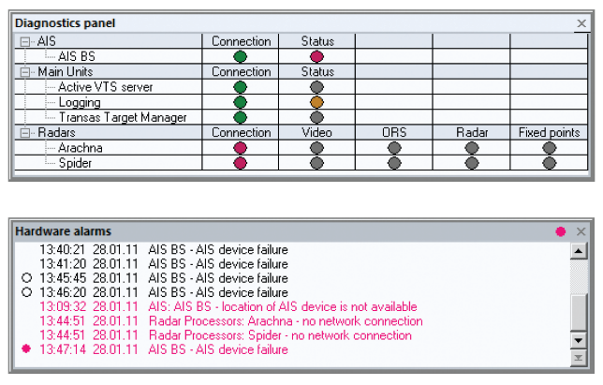

Figure 3‑12 Diagnostic Panel

The Diagnostics panel shows the following radar states:

* **Connection** – status of the radar processor connection with the VTS server;
* **Video** – supply of radar video data from the radar processor;
* **ORS** – supply of input signal from the radar to the radar processor, or RP OK
* **Radar** – radar fitness;
* **Fixed points** – fixed radar points:
  + **Green** – fixed point tracked
  + **Red** – fixed point lost

If there are any malfunctions in the radar, the Hardware alarms window provides a” Radar processors <name> – fault type” alarm.